**import** numpy **as** np *# linear algebra*

**import** pandas **as** pd *# data processing, CSV file I/O (e.g. pd.read_csv)*

**import** matplotlib.pyplot **as** plt

**import** seaborn **as** sns

**import** random

*# Input data files are available in the "../input/" directory.*

*# For example, running this (by clicking run or pressing Shift+Enter) will list all files under the input directory*

**import** os

**for** dirname, _, filenames **in** os**.**walk('/kaggle/input'):

**for** filename **in** filenames:

print(os**.**path**.**join(dirname, filename))

*# Any results you write to the current directory are saved as output.*

**%**matplotlib inline

In [14]:

data **=** pd**.**read_csv('/content/rainfall_India_2017.csv')**.**rename(columns**=**str**.**lower)

data**.**groupby('subdivision')[['annual']]**.**mean()**.**sort_values('annual')**.**tail(3)**.**plot**.**barh(title**=**'Top Most Highest Rainfalling Subdivision (3)',color**=**'gold',legend**=False**);

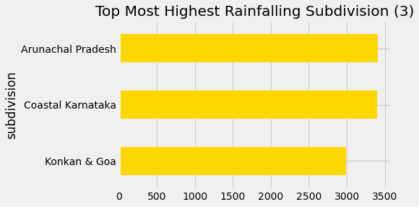

In [18]:

li **=** ['jan', 'feb', 'mar', 'apr', 'may', 'jun', 'jul',

'aug', 'sep', 'oct', 'nov', 'dec']

h **=** data**.**drop(li,axis**=**1)**.**dropna()**.**sort_values('annual')**.**head(1)**.**values**.**tolist()

l **=** data**.**drop(li,axis**=**1)**.**dropna()**.**sort_values('annual')**.**tail(1)**.**values**.**tolist()

print('\nThe highest {} millimeter rainfall happens in {} & the year of {}. '**.**format(l[0][2],l[0][0],l[0][1]))

print('\nThe lowest {} millimeter rainfall happens in {} & the year of {}. '**.**format(h[0][2],h[0][0],h[0][1]))

The highest 6331.1 millimeter rainfall happens in Arunachal Pradesh & the year of 1948.

The lowest 62.3 millimeter rainfall happens in West Rajasthan & the year of 1918.

In [19]:

plt**.**style**.**use('seaborn-poster')

ax **=** data**.**drop(['annual','year'],axis**=**1)**.**groupby('subdivision')**.**sum()**.**sort_values('jul')**.**plot**.**bar(stacked**=True**,figsize**=**(16, 8),

title**=**'Monthly Rainfalls of All Subdivision')

ax**.**set_xlabel('Subdivision')

ax**.**set_ylabel('Rainfalls (mm)')

patches, labels **=** ax**.**get_legend_handles_labels()

ax**.**legend(patches, labels, loc**=**'upper left',ncol**=**6,borderaxespad**=**.1)

plt**.**show()

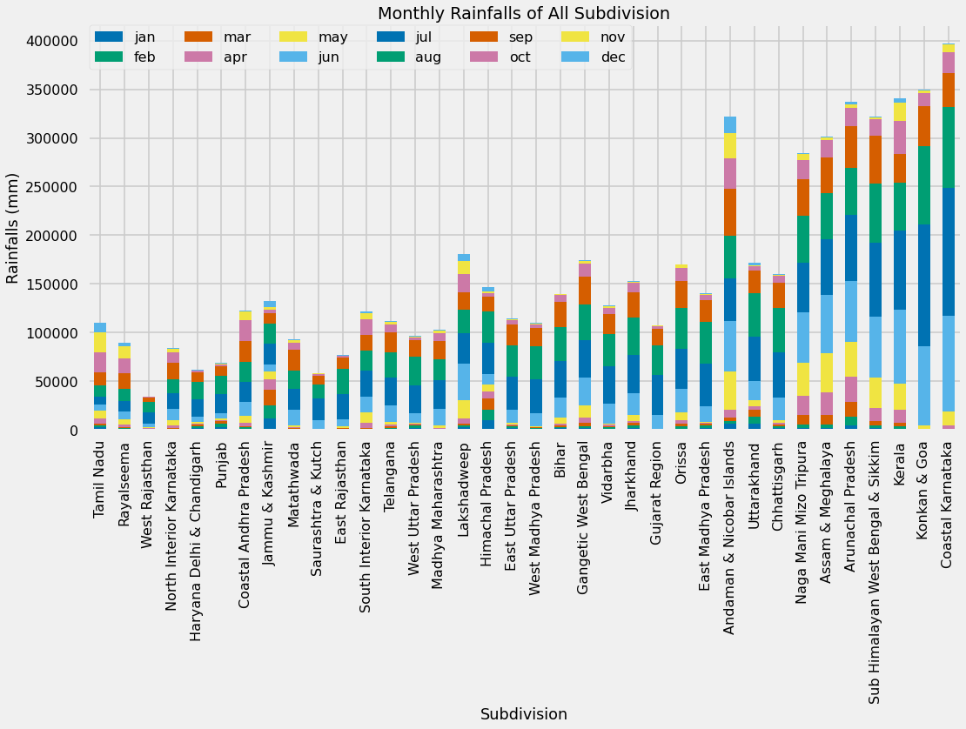

In [20]:

data**.**groupby('year')['annual']**.**sum()**.**rolling(10)**.**mean()**.**plot(title**=**'Rainfall of 10 Years Average Of The 117 Years',figsize**=**(14,6),linewidth**=**2,c**=**'mediumvioletred',marker**=**'*');

